JAVA 8 FEATUERES

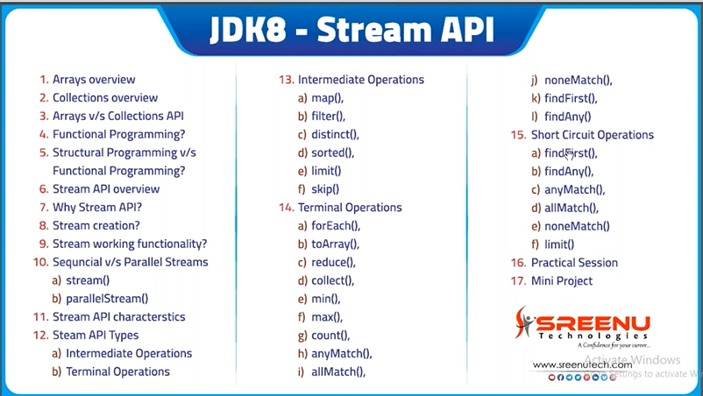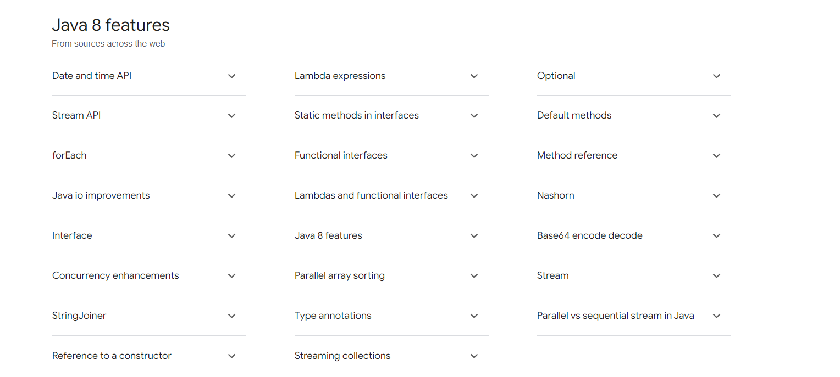
3 MAIN Reason for JAVA 8 (Why Java 8 came)
- Concise And Minimal Code
- we were missing functional befits in OOPS, To Utilize the functional benefits in java, JAVA8 came. But still it is in OOP language
- To Enable Parallel Programming.More compatible Code for Multi core processor
Features Of java 8
lambda Expression are similar to methods, but they do not need a name and they can be implemented right in the body of a method.
Example of lambda Expression is : (x,y) -> x+y.
Stream API : for bulk data Operation on collection.
The Stream API in Java is a powerful feature introduced in Java 8 that allows you to process sequences of data (collections like lists, arrays, etc.) in a functional and declarative manner. It provides a way to work with collections and arrays by applying operations such as filtering, mapping, reducing, and more in a concise and readable way.
Date And Time API : Under the package of java.time Java 8 Offers a new date-time API.
Base64 Encode Decode: for Base64 java 8 has built in encode and decode function.for Base64 encoding a class is Java.util.base64.
Method reference and constructor reference :: Operator
Default Methods in Interface, stataic method in Interface
functional Interface : A functional Interface is an Interface that that exactly one abstract Method. TO Designate a functional Interface we Don’t Need to use the @FunctionalInterface annotation
Optional Class : Java IO Improvements Collection API Improvments
+++++++++++++++++++++++++++++++++++++++++++++++++++++++++++
lambda Expression are similar to methods, but they do not need a name and they can be implemented right in the body of a method.
Example of lambda Expression is : (x,y) -> x+y.
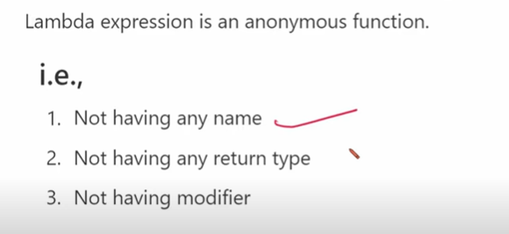
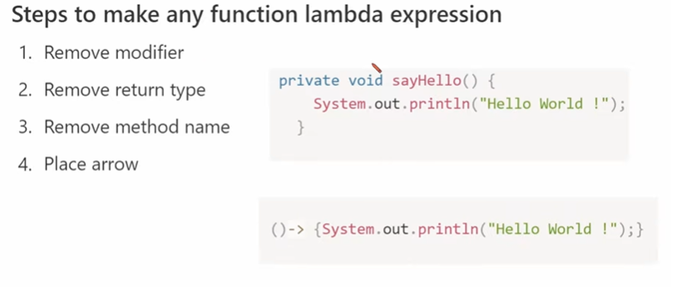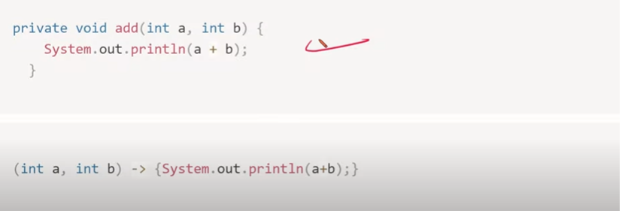

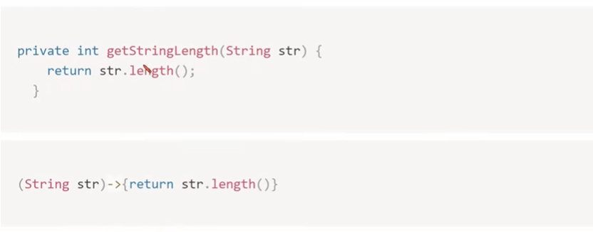
If a body has only one statement we can remove curly braces
(String str) ->{system.out.println(str)}; ==> (String str) ->system.out.println(str);

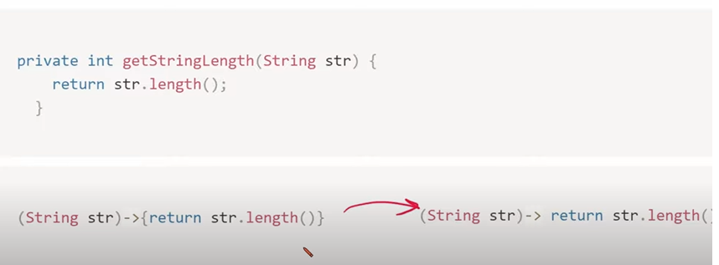
@FunctionalInterface
interface Adder {
int add(int a, int b);
}

public class LambdaExample {
public static void main(String[] args) {
// Define a lambda expression
Adder a = (int x, int y) -> {
return x + y;
};

// Use the lambda expression
int result = a.add(5, 2);
System.out.println("Result: " + result);
}
}

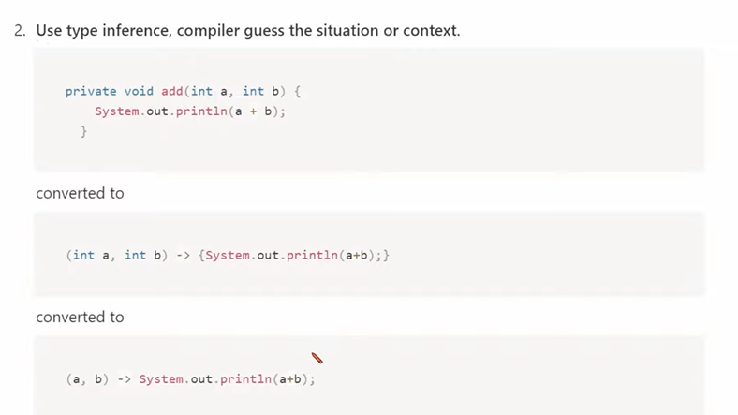
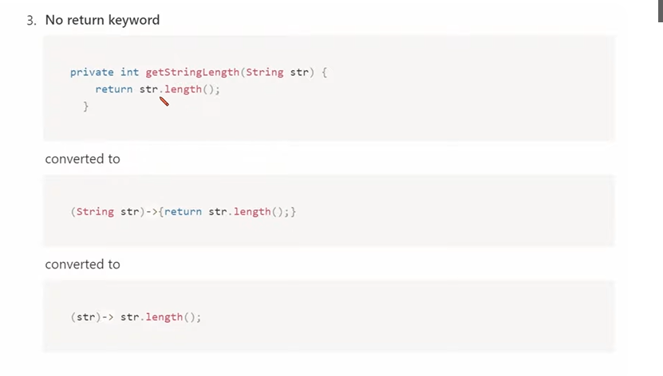

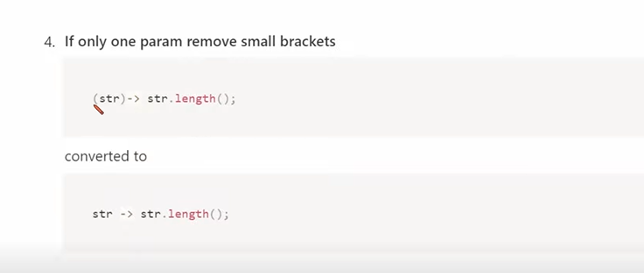

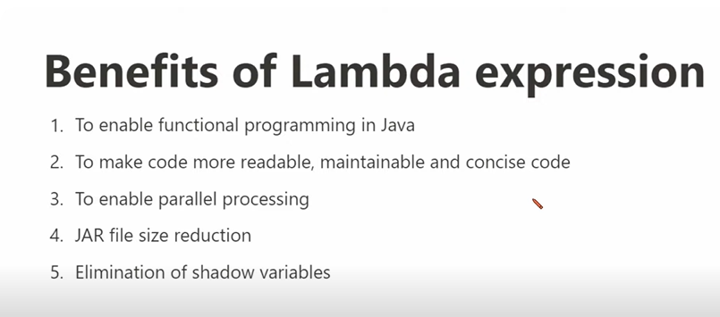

Where to use Lambada Expression :Functional Interface
Functional Interface : having exactly single abstract method but can have any number of default and static methods.we can invoke lambda expression by using functional interface
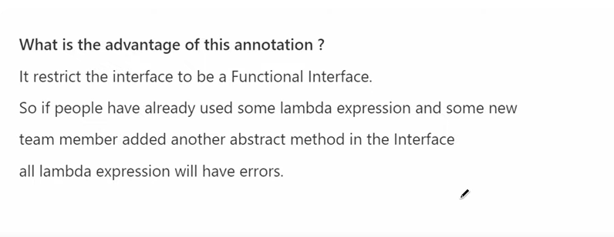

Inheritence in functional Inheritence
@FunctionalInterface
interface Greet {
void say(String message);
}

Greet greet = message -> System.out.println("Hello " + message);
greet.say("World");

Default Method
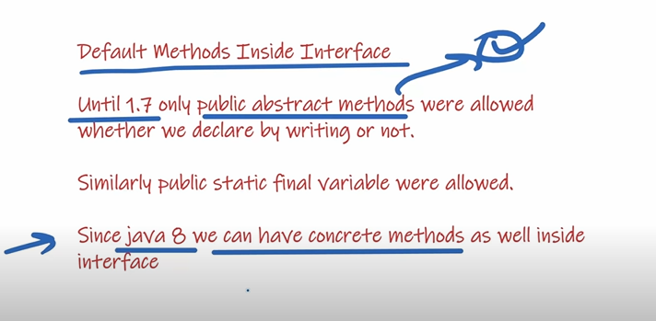
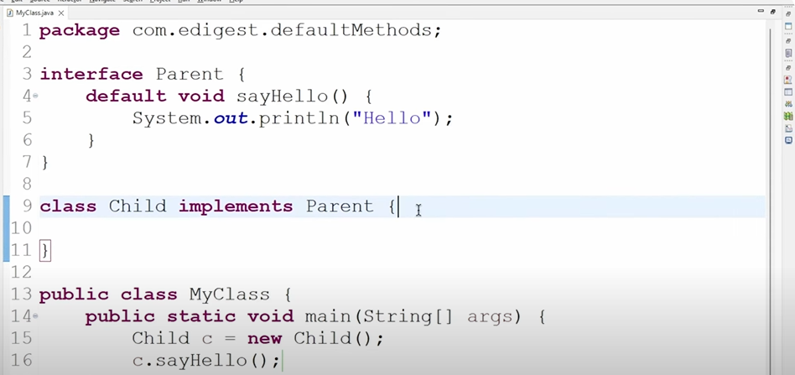

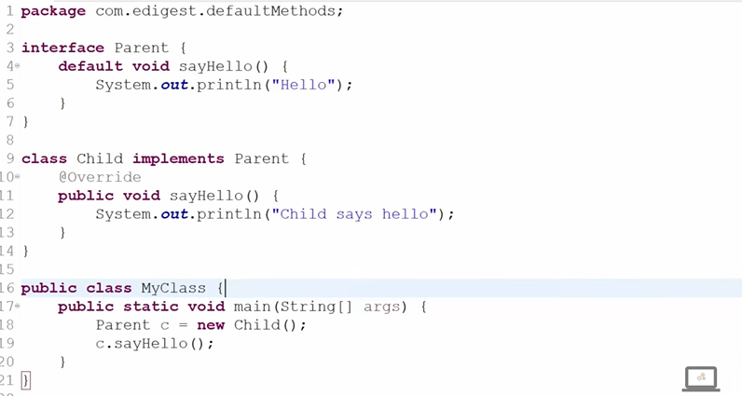

Default Methods
Will below programm wil give error?????
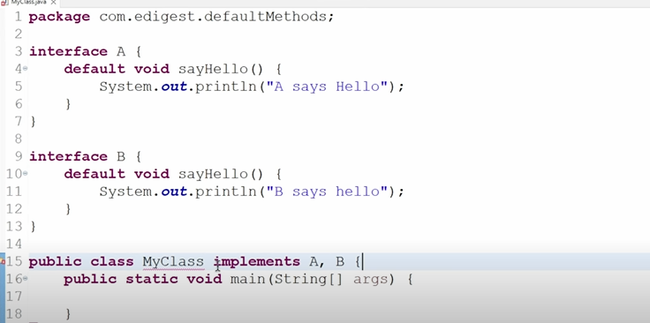

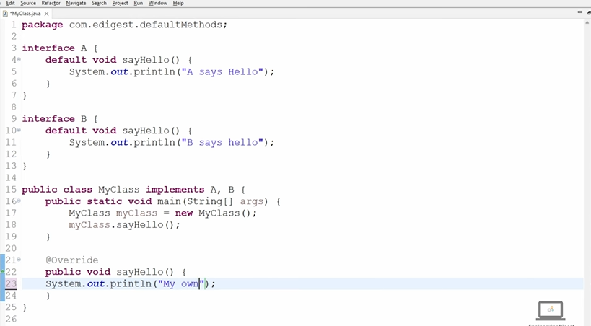

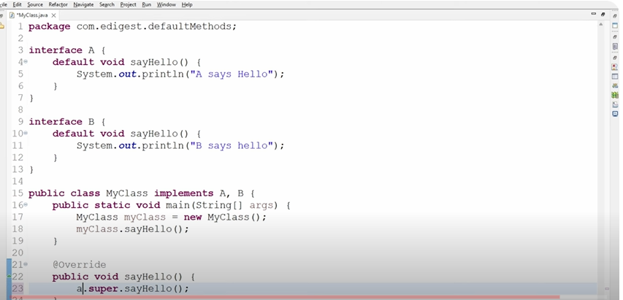
Static Method
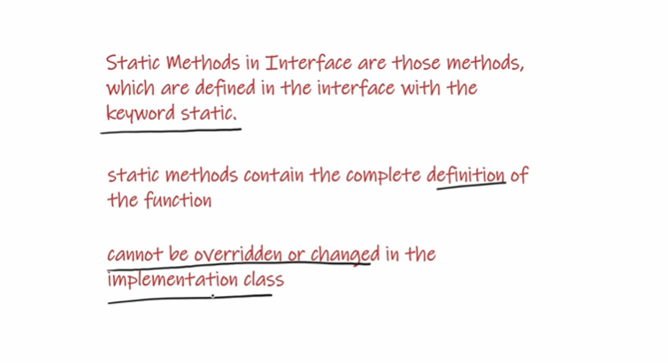

The correct way to call the static methods of Interface is using by InterfaceName.Method Nmae
in Below programm Obj.sayhello() and MyClass.sayhello() wont work. We need to call static methods using A.sayHello();
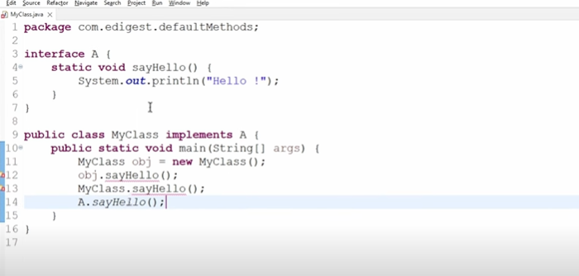

We can not override the static methods. In below program In Line 10 new method will be treated for class MyClass. It can not override static method of Interface
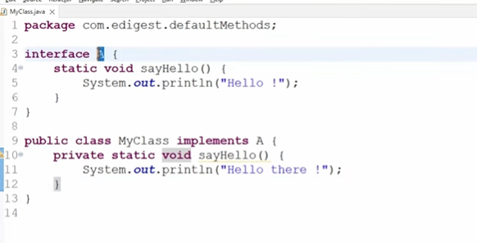

We can create the main methods inside the Interface because main is static method. We can run also , no error in compile and run in jdk 8.
but in below jdk 8 it will give error…. this proves that after java 8 only static methods is allowed in java.
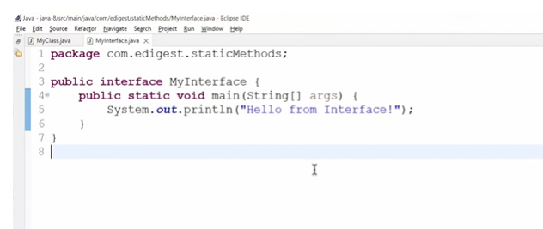

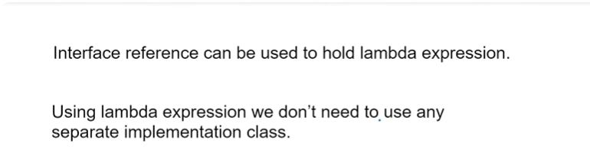

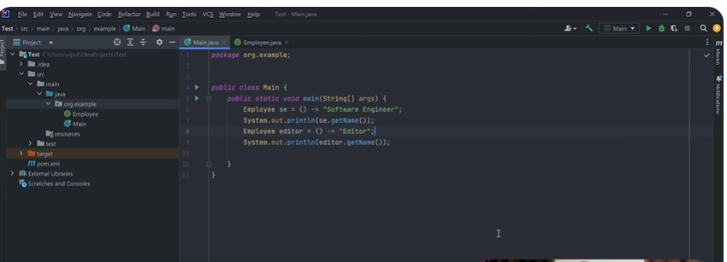

Create a Thread Using lambda Expression
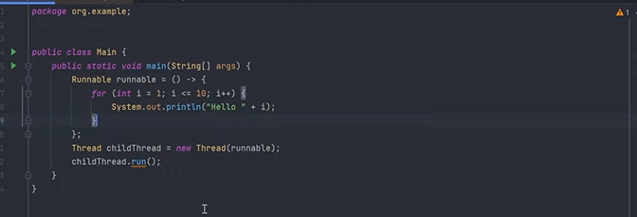

How To Use Comparator In Java
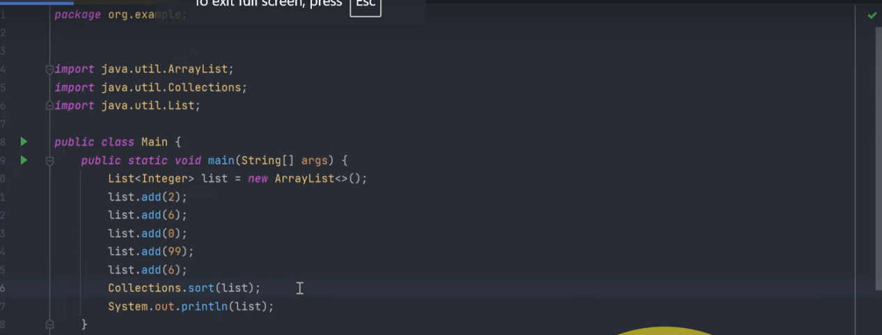

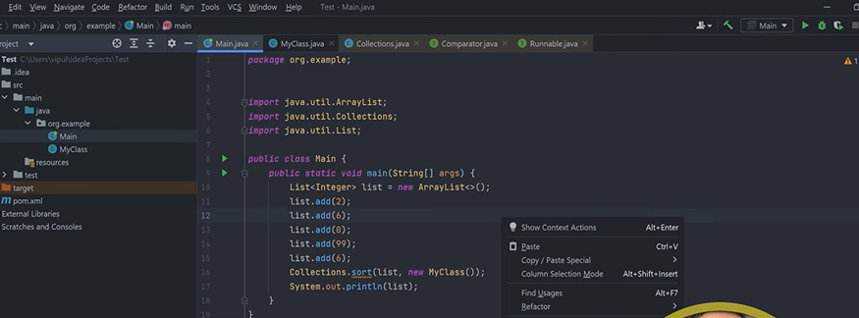
To Reverse it the comaparator comes in Between (Comparator is a functional Interface has only one abstarct method I.e compare(Obj a , Obj b)
Below code will revere in ordere usig lambada expression by using comaparator Interface
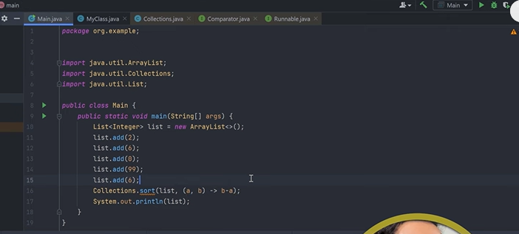
no need to mpletement in My class , Now we can delete it
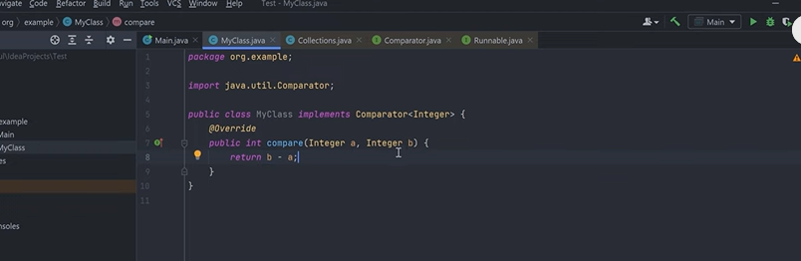)
Reverse using Treeset (In TreeSet values stored in ascending Order and after comaparator use it stored n Descending order)
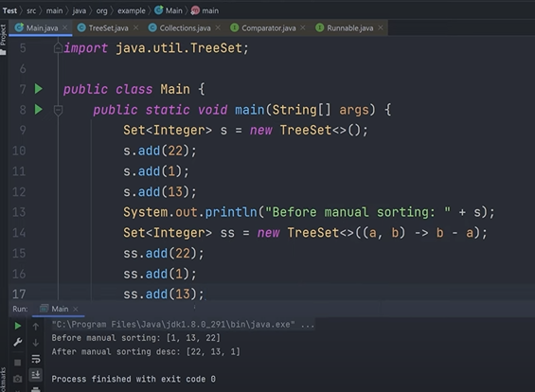

Reverse using TreeMap(In TreeMap values stored in ascending Order and after comaparator use it stored n Descending order)
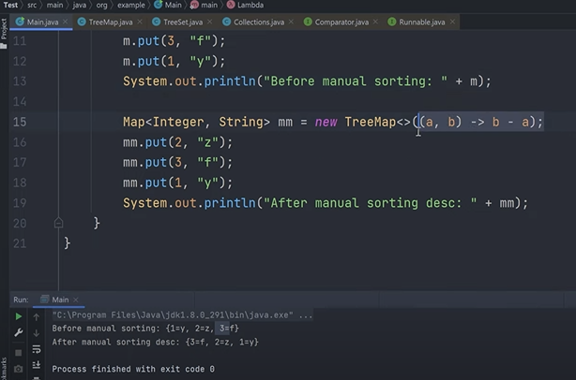

Custom Object in Descending Order Using
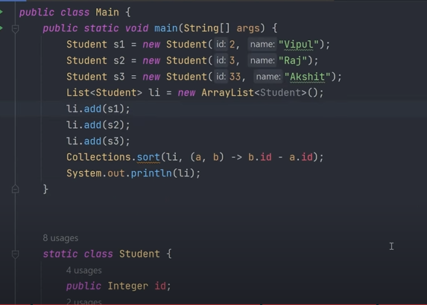
Difference Between Lambda and anonymous inner class………

Annonymous inner class instead of lambda because of two mehods are in Employeee interface
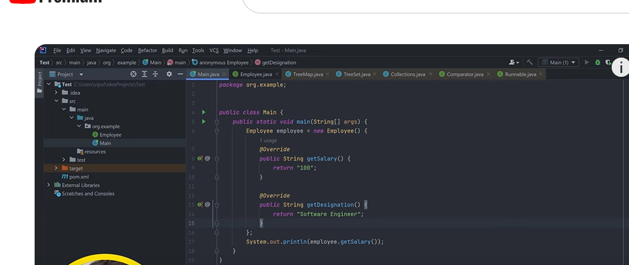

Using lambda
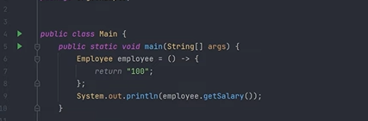
In Java 8, Predicate, Function, and Consumer are part of the java.util.function package, and they are examples of functional interfaces that are designed for use in lambda expressions and method references.
********************************************************************
Predicate : is a functional Interface
boolean test(T t);
Default methods (AND, OR, Negate) and static method (isEqual)
In Java 8, a Predicate is a functional interface that represents a single argument function that returns a boolean value. It is part of the java.util.function package and is commonly used for filtering or testing conditions on objects.
import java.util.function.Predicate;
*****************************************************************
@FunctionalInterface
public interface Predicate<T> {
boolean test(T t);

// Default methods (AND, OR, Negate) and static method (isEqual)
}
***************************************************************
public class PredicateExample {
public static void main(String[] args) {
// Predicate to check if a number is greater than 10
Predicate<Integer> isGreaterThanTen = number -> number > 10;

// Test the predicate
System.out.println(isGreaterThanTen.test(15)); // true
System.out.println(isGreaterThanTen.test(8)); // false
}
}

Common Use Cases:
Filtering Collections:
  - Predicate is often used with streams to filter collections based on a condition.
List<String> names = Arrays.asList("John", "Jane", "Jack", "Doe");

// Filter names starting with 'J'
List<String> filteredNames = names.stream()
.filter(name -> name.startsWith("J"))
.collect(Collectors.toList());

System.out.println(filteredNames); // [John, Jane, Jack]
Composing Predicates:
2 . Predicate comes with several default methods that allow you to compose predicates:
  - and(Predicate other): Combines this predicate with another using logical AND.
  - or(Predicate other): Combines this predicate with another using logical OR.
  - negate(): Returns a predicate that represents the logical negation of this predicate.
Predicate<Integer> isEven = number -> number % 2 == 0;
Predicate<Integer> isPositive = number -> number > 0;

// Combined predicate: even and positive
Predicate<Integer> isEvenAndPositive = isEven.and(isPositive);

System.out.println(isEvenAndPositive.test(4)); // true
System.out.println(isEvenAndPositive.test(-4)); // false
System.out.println(isEvenAndPositive.test(3)); // false

Static Methods:
- isEqual(Object targetRef): Returns a predicate that tests if two arguments are equal. It uses Objects.equals() for equality checks.

Predicate<String> isEqualToHello = Predicate.isEqual("Hello");

System.out.println(isEqualToHello.test("Hello")); // true
System.out.println(isEqualToHello.test("World")); // false

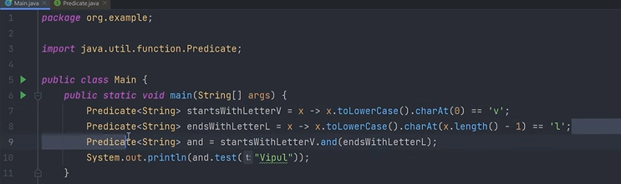

Predicated checks the condition but function works and return
Function : In Java 8, the Function interface is a functional interface that represents a function that takes one argument and returns a result. It is part of the java.util.function package and is commonly used for mapping or transforming data.
@FunctionalInterface
public interface Function<T, R> {
R apply(T t);

// Default methods (andThen, compose) and static method (identity)
}
import java.util.function.Function;

public class FunctionExample {
public static void main(String[] args) {
// Function to convert a string to its length
Function<String, Integer> stringLength = str -> str.length();

// Apply the function
int length = stringLength.apply("Hello, World!");

System.out.println("Length of the string: " + length); // Output: 13
}
}
T and R:
- T: The type of the input to the function. In the example above, T is String.
- R: The type of the result of the function. In the example above, R is Integer.

Common Use Cases:
Mapping/Transforming Data:
  - Function is often used in streams to map or transform elements in a collection.
List<String> names = Arrays.asList("John", "Jane", "Jack");
// Convert each name to its length
List<Integer> lengths = names.stream()
.map(name -> name.length())
.collect(Collectors.toList());

System.out.println(lengths); // [4, 4, 4]
Composing Functions:
- Function provides default methods for composing multiple functions:
  - andThen(Function after): Returns a composed function that first applies this function to its input, and then applies the after function to the result.
  - compose(Function before): Returns a composed function that first applies the before function to its input, and then applies this function to the result.
Function<String, String> addHello = str -> "Hello " + str;
Function<String, String> addExclamation = str -> str + "!";
// Combine functions: first add "Hello ", then add "!"
Function<String, String> combinedFunction = addHello.andThen(addExclamation);
System.out.println(combinedFunction.apply("World")); // Output: Hello World!
Identity Function:
- The identity() method returns a function that always returns its input argument. It's useful when you need a function but don't want to transform the data.
Function<Integer, Integer> identityFunction = Function.identity();
System.out.println(identityFunction.apply(5)); // Output: 5
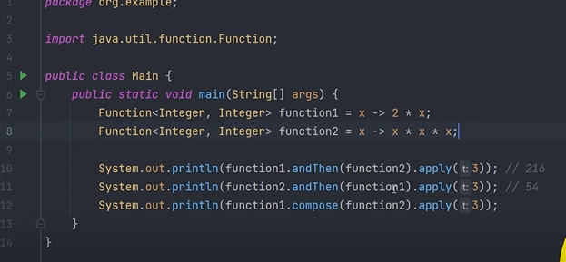
Consumer
In Java 8, the Consumer interface is a functional interface that represents an operation that takes a single input argument and returns no result. It is part of the java.util.function package and is typically used to perform operations on an object, such as printing, modifying, or logging.
import java.util.function.Consumer;
public class ConsumerExample {
public static void main(String[] args) {
// Consumer to print a string
Consumer<String> printConsumer = str -> System.out.println(str);
// Using the Consumer to print a message
printConsumer.accept("Hello, World!"); // Output: Hello, World!
}
}

T (Generic Type Parameter):
- T is the type of the input to the Consumer. It allows the Consumer to be used with any type of object. For example, if you want a Consumer that works with String objects, T would be String.
Consumer is often used in combination with the forEach method to perform actions on each element of a collection.
List<String> names = Arrays.asList("John", "Jane", "Jack");
// Print each name in the list
names.forEach(name -> System.out.println(name));
The Consumer interface provides a default method called andThen, which allows you to chain multiple Consumer operations. The first Consumer is executed, followed by the second one.
Consumer<String> printConsumer = str -> System.out.println("Printing: " + str);
Consumer<String> upperCaseConsumer = str -> System.out.println(str.toUpperCase());
// Chain Consumers: first print, then convert to upper case and print
Consumer<String> combinedConsumer = printConsumer.andThen(upperCaseConsumer);
combinedConsumer.accept("hello"); // Output: Printing: hello // HELLO

Consumer can be used to modify objects, such as updating fields or applying transformations.
Consumer<StringBuilder> appendConsumer = sb -> sb.append(" World");
StringBuilder sb = new StringBuilder("Hello");
appendConsumer.accept(sb);
System.out.println(sb.toString()); // Output: Hello World
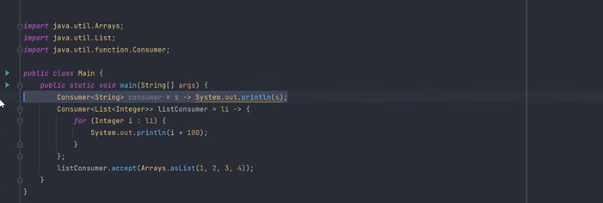
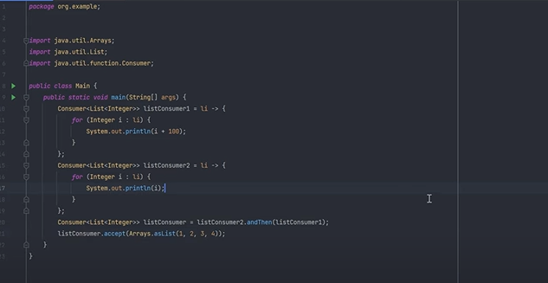

Supplier

In Java 8, the Supplier interface is a functional interface that represents a supplier of results. Unlike Consumer, which takes an input and returns nothing, Supplier takes no input and returns a result. It is part of the java.util.function package and is commonly used when you need to generate or supply values without any input, such as creating objects, providing default values, or lazy initialization.
@FunctionalInterface
public interface Supplier<T> {
T get();
}
import java.util.function.Supplier;

public class SupplierExample {
public static void main(String[] args) {
// Supplier to provide the current date and time
Supplier<String> dateSupplier = () -> java.time.LocalDateTime.now().toString();

// Using the Supplier to get the current date and time
System.out.println("Current Date and Time: " + dateSupplier.get());
}
}
Supplier can be used to generate values, such as random numbers, unique IDs, or default values.
Supplier<Double> randomSupplier = () -> Math.random();
// Get a random value
System.out.println("Random value: " + randomSupplier.get());
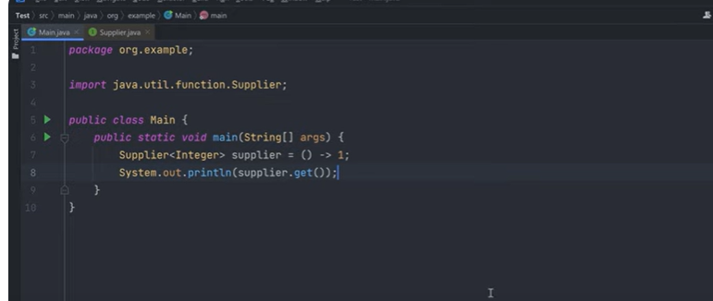
Predicate, Consumer, Suuplier and Function in One Frame
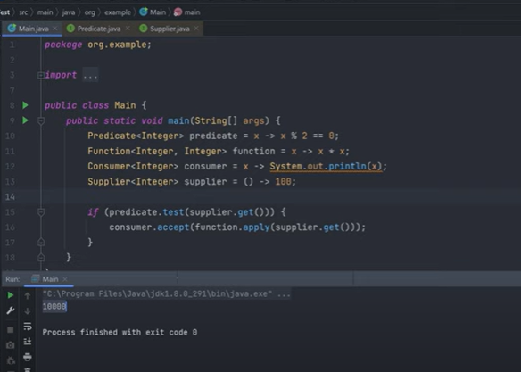
BiPredicate, BiFunction, and BiConsumer
In Java 8, BiPredicate, BiFunction, and BiConsumer are functional interfaces that are similar to Predicate, Function, and Consumer, respectively, but they take two arguments instead of one. These interfaces are part of the java.util.function package and are used to perform operations on two input values.
BiPredicate
BiPredicate is a functional interface that represents a predicate (a boolean-valued function) of two arguments.
boolean test(T t, U u): Takes two arguments of types T and U and returns a boolean value based on a condition.
@FunctionalInterface
public interface BiPredicate<T, U> {
boolean test(T t, U u);
}
import java.util.function.BiPredicate;

public class BiPredicateExample {
public static void main(String[] args) {
// BiPredicate to check if two strings are equal ignoring case
BiPredicate<String, String> equalsIgnoreCase = (str1, str2) -> str1.equalsIgnoreCase(str2);

// Test the BiPredicate
System.out.println(equalsIgnoreCase.test("Hello", "hello")); // true
System.out.println(equalsIgnoreCase.test("Hello", "world")); // false
}
}

BiFunction
BiFunction is a functional interface that represents a function that takes two arguments and produces a result.
@FunctionalInterface
public interface BiFunction<T, U, R> {
R apply(T t, U u);
// Default methods for chaining (andThen)
}
import java.util.function.BiFunction;
public class BiFunctionExample {
public static void main(String[] args) {
// BiFunction to concatenate two strings with a space in between
BiFunction<String, String, String> concatenate = (str1, str2) -> str1 + " " + str2;

// Apply the BiFunction
String result = concatenate.apply("Hello", "World");
System.out.println(result); // Output: Hello World
}
}

BiConsumer
BiConsumer is a functional interface that represents an operation that takes two input arguments and returns no result. It is used to perform an action with two input values, such as printing, modifying, or processing the inputs.
import java.util.function.BiConsumer;
public class BiConsumerExample {
public static void main(String[] args) {
// BiConsumer to print two values
BiConsumer<String, Integer> printDetails = (name, age) -> System.out.println(name + " is " + age + " years old");
// Use the BiConsumer
printDetails.accept("John", 25); // Output: John is 25 years old
}
}
unary And Binary operator
In Java 8, UnaryOperator and BinaryOperator are functional interfaces that extend the Function interface.
The UnaryOperator<T> is a functional interface that represents an operation on a single operand of type T and produces a result of the same type T. It extends the Function<T, T> interface.
@FunctionalInterface
public interface UnaryOperator<T> extends Function<T, T> {
// Single abstract method
T apply(T t);
}
import java.util.function.UnaryOperator;
public class UnaryOperatorExample {
public static void main(String[] args) {
// Example of using UnaryOperator to increment a number
UnaryOperator<Integer> increment = x -> x + 1;
System.out.println(increment.apply(5)); // Output: 6
// Example of using UnaryOperator to negate a number
UnaryOperator<Integer> negate = x -> -x;
System.out.println(negate.apply(5)); // Output: -5
}
}

BinaryOperator Interface
The BinaryOperator<T> is a functional interface that represents an operation upon two operands of the same type T, producing a result of the same type T. It extends the BiFunction<T, T, T> interface.
@FunctionalInterface
public interface BinaryOperator<T> extends BiFunction<T, T, T> {
// Single abstract method
T apply(T t1, T t2);
}
import java.util.function.BinaryOperator;
public class BinaryOperatorExample {
public static void main(String[] args) {
// Example of using BinaryOperator to add two numbers
BinaryOperator<Integer> add = (x, y) -> x + y;
System.out.println(add.apply(5, 3)); // Output: 8
// Example of using BinaryOperator to multiply two numbers
BinaryOperator<Integer> multiply = (x, y) -> x * y;
System.out.println(multiply.apply(5, 3)); // Output: 15
}
}

Use Cases
- UnaryOperator: Commonly used for operations that transform a single input value, such as incrementing, negating, or converting a value.
- BinaryOperator: Useful for operations that combine two values, such as addition, subtraction, multiplication, or concatenation.

constructor reference
A constructor reference in Java is a shorthand syntax for creating instances of a class using a functional interface. It allows you to refer to a constructor without explicitly invoking it, and it’s particularly useful when working with streams or when passing constructors as arguments to higher-order functions.
Syntax:
The syntax for a constructor reference is:
ClassName::new

Example 1: Using Constructor Reference with Supplier
Let's consider a simple example where we use a constructor reference with the Supplier functional interface.
import java.util.function.Supplier;
public class Example {
public static void main(String[] args) {
// Constructor reference to create a new instance of the Example class
Supplier<Example> exampleSupplier = Example::new;

// Using get() to create a new instance
Example exampleInstance = exampleSupplier.get();

System.out.println("Instance created: " + exampleInstance);
}

// Constructor
public Example() {
System.out.println("Example constructor called!");
}
}

Example 2: Using Constructor Reference with Function
Suppose you have a class Person that has a constructor taking a single String argument for the name. You can use a constructor reference with the Function functional interface to create instances.
import java.util.function.Function;
class Person {
String name;
// Constructor
public Person(String name) {
this.name = name;
}
@Override
public String toString() {
return "Person{name='" + name + "'}";
}
}
public class ConstructorReferenceExample {
public static void main(String[] args) {
// Constructor reference to create a new Person with a name
Function<String, Person> personCreator = Person::new;
// Using apply() to create a new instance of Person
Person person = personCreator.apply("Bhaskar");
System.out.println(person);
}
}
output

Person{name='Bhaskar'}
Example 3: Constructor Reference with Array
You can also use constructor references to create arrays.
import java.util.function.IntFunction;
public class ArrayConstructorReference {
public static void main(String[] args) {
// Constructor reference for creating an array of integers
IntFunction<int[]> arrayCreator = int[]::new;
// Create an array of length 5
int[] array = arrayCreator.apply(5);
System.out.println("Array length: " + array.length);
}
}
Array length: 5

Method And Constructor Reference:
Method and constructor references are shorthand notations in Java 8 that allow you to refer to methods or constructors without invoking them.
Method reference and constructor reference can be used in place of lambda expression.
import java.util.function.Function;
public class MethodReferenceExample {
public static void main(String[] args) {
// Using a lambda expression
Function<String, Integer> lambda = s -> Integer.parseInt(s);
// Using a method reference
Function<String, Integer> methodRef = Integer::parseInt;
System.out.println(lambda.apply("123")); // Output: 123
System.out.println(methodRef.apply("123")); // Output: 123
}
}
Reference to an Instance Method of a Particular Object
- Syntax: instance::instanceMethodName
import java.util.functon.Supplier;
public class MethodReferenceExample {
public static void main(String[] args) {
String str = "Hello, World!";
// Using a lambda expression
Supplier<String> lambda = () -> str.toUpperCase();
// Using a method reference
Supplier<String> methodRef = str::toUpperCase;
System.out.println(lambda.get()); // Output: HELLO, WORLD!
System.out.println(methodRef.get()); // Output: HELLO, WORLD!
}
}
Reference to an Instance Method of an Arbitrary Object of a Particular Type
- Syntax: ClassName::instanceMethodName
import java.util.Arrays;
import java.util.List;

public class MethodReferenceExample {
public static void main(String[] args) {
List<String> list = Arrays.asList("apple", "banana", "cherry");
// Using a lambda expression
list.forEach(s -> System.out.println(s));
// Using a method reference
list.forEach(System.out::println);
}
}
Reference to a Constructor
- Syntax: ClassName::new
import java.util.function.Supplier;
public class ConstructorReferenceExample {
public static void main(String[] args) {
// Using a lambda expression
Supplier<StringBuilder> lambda = () -> new StringBuilder();
// Using a constructor reference
Supplier<StringBuilder> constructorRef = StringBuilder::new;
System.out.println(lambda.get().append("Lambda")); // Output: Lambda
System.out.println(constructorRef.get().append("Constructor Ref")); // Output: Constructor Ref
}
}
Reference to a Class Constructor
- Syntax: ClassName::new
import java.util.function.Function;
public class ConstructorReferenceExample {
public static void main(String[] args) {
// Using a lambda expression
Function<String, Integer> lambda = s -> new Integer(s);
// Using a constructor reference
Function<String, Integer> constructorRef = Integer::new;
System.out.println(lambda.apply("123")); // Output: 123
System.out.println(constructorRef.apply("123")); // Output: 123
}
}
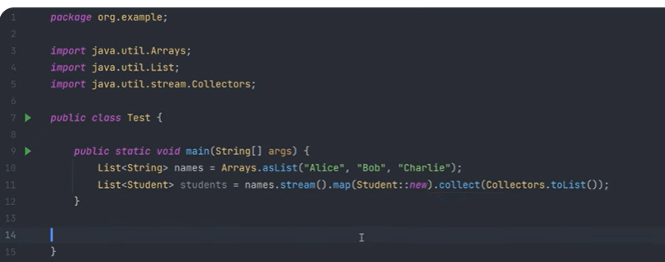
*********************************************************************************
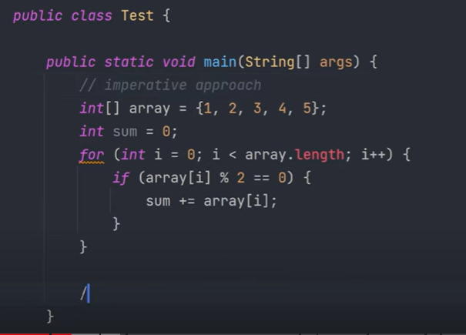

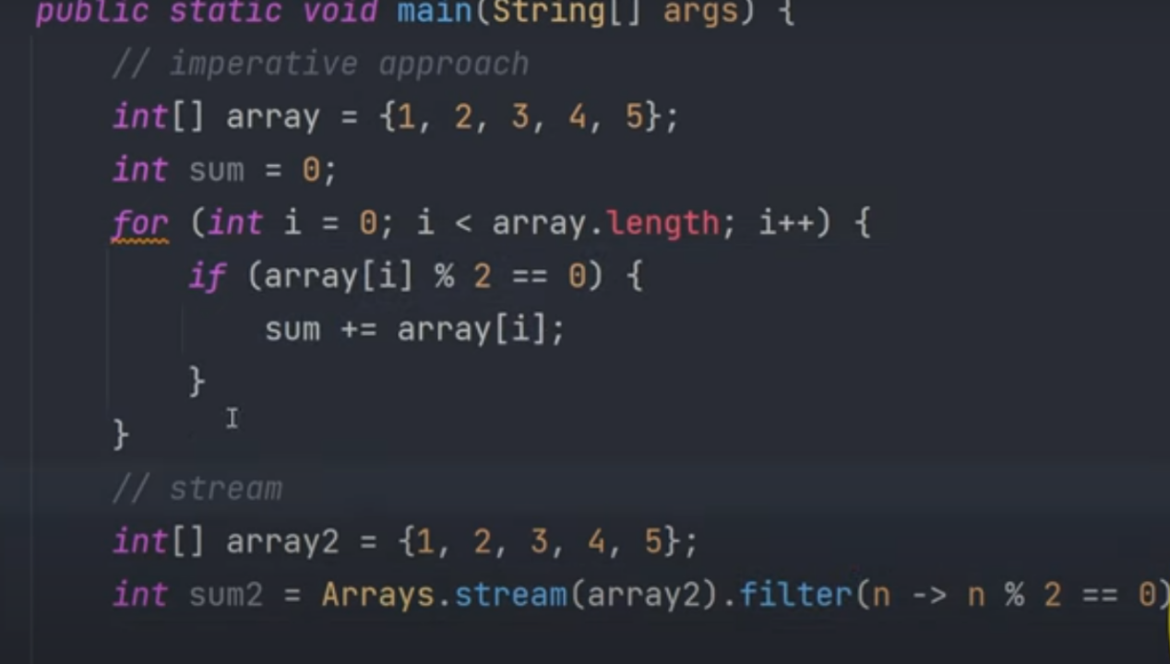
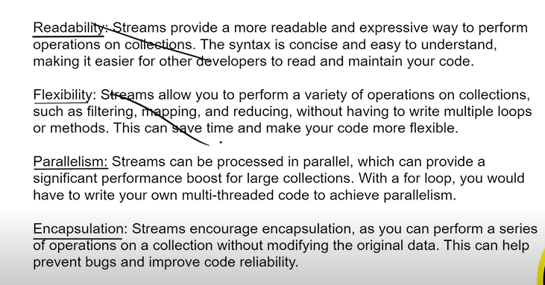
Convert In To Stream
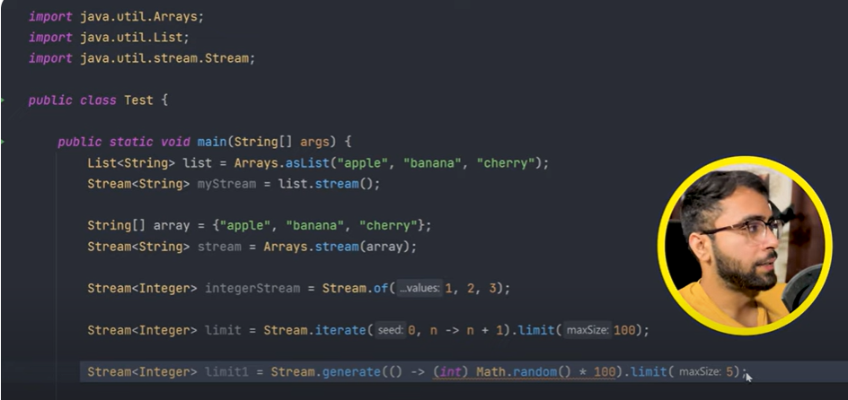
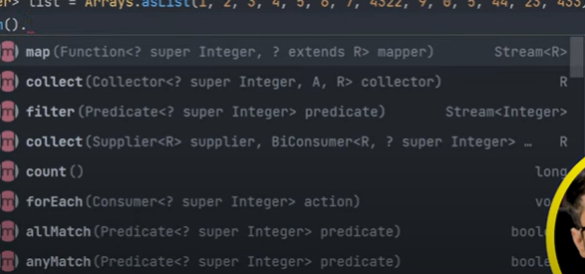
Filter() Method
In Java 8, the filter method is a powerful feature of the Stream API. It allows you to filter elements of a stream based on a given predicate (a condition) and return a new stream consisting of elements that match the condition.
Basic Usage of filter
The filter method takes a Predicate as an argument. A Predicate is a functional interface that represents a condition (a boolean-valued function) to be checked on each element of the stream.
Syntex
Stream<T> filter(Predicate<? super T> predicate)
Filtering Even Numbers from a List
import java.util.Arrays;
import java.util.List;
import java.util.stream.Collectors;
public class FilterExample {
public static void main(String[] args) {
List<Integer> numbers = Arrays.asList(1, 2, 3, 4, 5, 6, 7, 8, 9, 10);
// Using filter to keep only even numbers
List<Integer> evenNumbers = numbers.stream()
.filter(n -> n % 2 == 0)
.collect(Collectors.toList());
System.out.println(evenNumbers); // Output: [2, 4, 6, 8, 10]
}
}
Filtering Strings Based on Length
import java.util.Arrays;
import java.util.List;
import java.util.stream.Collectors;

public class FilterExample {
public static void main(String[] args) {
List<String> names = Arrays.asList("John", "Jane", "Max", "Alexa", "Sam");

// Using filter to keep only names with length greater than 3
List<String> longNames = names.stream()
.filter(name -> name.length() > 3)
.collect(Collectors.toList());

System.out.println(longNames); // Output: [John, Jane, Alexa]
}
}

Filtering Objects Based on a Condition
Let's consider a more complex example where you have a list of Person objects, and you want to filter only those who are above a certain age.
java
Copy code
import java.util.Arrays;import java.util.List;import java.util.stream.Collectors;
class Person {
String name;
int age;

Person(String name, int age) {
this.name = name;
this.age = age;
}

@Override
public String toString() {
return name + " (" + age + ")";
}
}
public class FilterExample {
public static void main(String[] args) {
List<Person> people = Arrays.asList(
new Person("John", 25),
new Person("Jane", 22),
new Person("Max", 30),
new Person("Alex", 18)
);

// Using filter to keep only people older than 24
List<Person> adults = people.stream()
.filter(person -> person.age > 24)
.collect(Collectors.toList());

System.out.println(adults); // Output: [John (25), Max (30)]
}
}

Chaining Filters
You can chain multiple filter calls to apply multiple conditions:
import java.util.Arrays;
import java.util.List;
import java.util.stream.Collectors;

public class FilterExample {
public static void main(String[] args) {
List<Integer> numbers = Arrays.asList(1, 2, 3, 4, 5, 6, 7, 8, 9, 10);

// Using multiple filters: keep only even numbers greater than 4
List<Integer> filteredNumbers = numbers.stream()
.filter(n -> n % 2 == 0)
.filter(n -> n > 4)
.collect(Collectors.toList());

System.out.println(filteredNumbers); // Output: [6, 8, 10]
}
}
MAP()

In Java 8, the map() method is a part of the Stream API and is used to transform each element of a stream by applying a given function. The map() operation produces a new stream consisting of the results of applying the function to the elements of the original stream. It is commonly used to perform transformations on data, such as converting types or extracting specific fields from objects.
Basic Usage of map()
The map() method takes a Function as an argument. A Function is a functional interface that represents a function that takes one argument and produces a result.

Syntax:
<R> Stream<R> map(Function<? super T, ? extends R> mapper)
Converting a List of Strings to Uppercase
package Practice.Map;

import java.util.Arrays;
import java.util.List;
import java.util.stream.Collectors;

public class useOfMap {

public static void main(String[] args) {
// TODO Auto-generated method stub
//map is used for Transforming elements

List<String> list = Arrays.asList("sagir","Sourabh","Vikas");
//uppercase
List<String> filteredList = list.stream().map(str -> str.toUpperCase()).collect(Collectors.toList());
List<String> filteredListUsingMethodreference = list
.stream()
.map(String::toUpperCase)
.collect(Collectors.toList());

filteredListUsingMethodreference.forEach(System.out :: println);
System.out.println();
// list.stream().map(String::toUpperCase).forEach(System.out :: print);

// take string and return length

List<Integer> filteredListUsingMethodreferenceLength = list
.stream()
.map(String::toUpperCase).map(String :: length)
.collect(Collectors.toList());

System.out.println(filteredListUsingMethodreferenceLength);
}

}

**
Mapping Objects to a Specific Field
Let's say you have a list of Person objects, and you want to create a list of their names.
import java.util.Arrays;import java.util.List;
Import java.util.stream.Collectors;
class Person {
String name;
int age;

Person(String name, int age) {
this.name = name;
this.age = age;
}

public String getName() {
return name;
}
}
public class MapExample {
public static void main(String[] args) {
List<Person> people = Arrays.asList(
new Person("John", 25),
new Person("Jane", 22),
new Person("Max", 30)
);

// Using map() to extract names from the list of Person objects
List<String> names = people.stream()
.map(Person::getName)
.collect(Collectors.toList());

System.out.println(names); // Output: [John, Jane, Max]
}
}

Flattening a List of Lists Using map() and flatMap()
If you have a list of lists and you want to flatten it into a single list, you can use map() in conjunction with flatMap().
import java.util.Arrays;
import java.util.List;
import java.util.stream.Collectors;
public class MapExample {
public static void main(String[] args) {
List<List<String>> listOfLists = Arrays.asList(
Arrays.asList("a", "b", "c"),
Arrays.asList("d", "e", "f"),
Arrays.asList("g", "h", "i")
);
// Using flatMap() to flatten the list of lists into a single list
List<String> flattenedList = listOfLists.stream()
.flatMap(List::stream)
.collect(Collectors.toList());
System.out.println(flattenedList); // Output: [a, b, c, d, e, f, g, h, i]
}
}
Some methods used in programs
package Practice.Map;

import java.util.Arrays;
import java.util.List;
import java.util.stream.Collectors;
import java.util.stream.Stream;

public class useOfMap {

public static void main(String[] args) {
// TODO Auto-generated method stub
//map is used for Transforming elements

List<String> list = Arrays.asList("sagir","Sourabh","Vikas");
//uppercase
List<String> filteredList = list.stream().map(str -> str.toUpperCase()).collect(Collectors.toList());
List<String> filteredListUsingMethodreference = list
.stream()
.map(String::toUpperCase)
.collect(Collectors.toList());

filteredListUsingMethodreference.forEach(System.out :: println);
System.out.println();
// list.stream().map(String::toUpperCase).forEach(System.out :: print);

// take string and return length

List<Integer> filteredListUsingMethodreferenceLength = list
.stream()
.map(String::toUpperCase).map(String :: length)
.collect(Collectors.toList());

System.out.println(filteredListUsingMethodreferenceLength);

List<Integer> Intlist = Arrays.asList(1,2,3,4,5,6,7,8,9,10,11,21,1,3,5,7,9,2,4,5,6,10000000,10000000,10000000);
List<Integer> filteredListInt = Intlist
.stream()
.filter(x -> x%2 == 0)
//.distinct() // unique elemets
.map(x -> x/2) // dividing filtered elemets by 2
.distinct() // geting unique lements
.peek(x -> System.out.print(x+" "))
.sorted((a,b) -> b-a) // sorting in descending order
.limit(4) // this much numberOfElements will appear
.skip(1) // skiped first elemet
.peek(x -> System.out.print(x+" ")) // takes consumer as argument and print
.collect(Collectors.toList());
System.out.println("++++++++++++++++++++++++++++++++");
filteredListInt.forEach(System.out :: println);
System.out.println("++++++++++++++++++++++++++++++++");

// use stream method to iterate

List<Integer> StreamList = Stream
.iterate(0, x -> x+1)
.limit(100)
.skip(1)
.collect(Collectors.toList());
System.out.println(StreamList);

long max = Intlist
.stream()
.filter(x -> x%2 == 0)
//.distinct() // unique elemets
.map(x -> x/2) // dividing filtered elemets by 2
.distinct() // geting unique lements
.peek(x -> System.out.print(x+" "))
.sorted((a,b) -> b-a) // sorting in descending order
.limit(4) // this much numberOfElements will appear
.skip(1) // skiped first elemet
.peek(x -> System.out.print(x+" ")) // takes consumer as argument and print
.max((a,b) -> a-b)
.get();
System.out.println();

System.out.println("============================================");
System.out.println("Maximum Element >> "+max);

long Count = Intlist
.stream()
.filter(x -> x%2 == 0)
//.distinct() // unique elemets
.map(x -> x/2) // dividing filtered elemets by 2
.distinct() // geting unique lements
.peek(x -> System.out.print(x+" ")) // for printing
.sorted((a,b) -> b-a) // sorting in descending order
.count(); // its a terminal operator ,once count is used no other operation can be performed

//min(), max(),Count() terminal operators
System.out.println();

System.out.println("============================================");
System.out.println("Count >> "+Count); //

}

}

All terminal Operators in Java 8
In Java 8's Stream API, terminal operations are those that terminate the stream pipeline, triggering the execution of all preceding intermediate operations, and producing a result or side effect. Once a terminal operation is invoked, the stream can no longer be used.
Here are some of the most commonly used terminal operations in the Stream API:

1. forEach()
- Description: Performs an action for each element of the stream.
List<String> names = Arrays.asList("John", "Jane", "Max");
names.stream().forEach(name -> System.out.println(name));

2. toArray()
- Description: Returns an array containing the elements of the stream.
String[] nameArray = names.stream().toArray(String[]::new);

3. reduce()
- Description: Performs a reduction on the elements of the stream using an associative accumulation function and returns an Optional.
int sum = numbers.stream().reduce(0, Integer::sum);
The reduce method in Java is a terminal operation in the Streams API that allows you to process and combine all elements of a stream into a single result. It is a powerful tool for performing aggregation operations, such as summing numbers, concatenating strings, or finding the maximum/minimum values in a collection.

4. collect()
- Description: Performs a mutable reduction operation on the elements of the stream using a Collector and returns the result. It's commonly used to collect elements into a List, Set, Map, etc.
List<String> nameList = names.stream().collect(Collectors.toList());

5. min() and max()
- Description: Returns the minimum or maximum element of the stream according to a provided comparator, wrapped in an Optional.
Optional<Integer> min = numbers.stream().min(Integer::compareTo);
Optional<Integer> max = numbers.stream().max(Integer::compareTo);

6. count()
Description: Returns the count of elements in the stream.
long count = names.stream().count();

7. anyMatch(), allMatch(), noneMatch()
- Description:
  - anyMatch(): Returns true if any element of the stream matches the provided predicate.
  - allMatch(): Returns true if all elements of the stream match the provided predicate.
  - noneMatch(): Returns true if no elements of the stream match the provided predicate.
boolean anyEven = numbers.stream().anyMatch(n -> n % 2 == 0);
boolean allPositive = numbers.stream().allMatch(n -> n > 0);
boolean noneNegative = numbers.stream().noneMatch(n -> n < 0);

8. findFirst() and findAny()
- Description:
  - findFirst(): Returns the first element of the stream, wrapped in an Optional.
  - findAny(): Returns any element of the stream, wrapped in an Optional. Particularly useful in parallel streams.
Optional<String> first = names.stream().findFirst();
Optional<String> any = names.stream().findAny();

9. summaryStatistics()
- Description: Returns a DoubleSummaryStatistics, IntSummaryStatistics, or LongSummaryStatistics object that contains statistics such as count, sum, min, average, and max.
IntSummaryStatistics stats = numbers.stream().mapToInt(Integer::intValue).summaryStatistics();

10. join() (via Collectors)
- Description: Joins the elements of the stream into a single String using a specified delimiter.
String joined = names.stream().collect(Collectors.joining(", "));

11. toMap() (via Collectors)
- Description: Collects the elements of the stream into a Map using key and value mappers.
Map<String, Integer> nameLengthMap = names.stream()
.collect(Collectors.toMap(name -> name, name -> name.length()));

12. partitioningBy() and groupingBy() (via Collectors)
- Description:
  - partitioningBy(): Partitions the elements into two groups based on a predicate.
  - groupingBy(): Groups the elements based on a classifier function
Map<Boolean, List<Integer>> partitioned = numbers.stream()
.collect(Collectors.partitioningBy(n -> n % 2 == 0));

Map<Integer, List<String>> grouped = names.stream()
.collect(Collectors.groupingBy(String::length));
parallel Stream ()
- It is meant for utilizing the various cores of the processor.
- Usually, any Java code that has only one processing stream, where it is sequentially executed.
- However, by using parallel streams, we can separate the Java code into more than one stream, which is executed in parallel on their separate cores, and the end result is the combination of the individual results.
The order in which they are executed is not in our control.
package parallelStream;

import java.util.stream.IntStream;

public class ParallelStreamExample {

public static void main(String[] args) {
// TODO Auto-generated method stub
long start = 0;
long end = 0;

start = System.currentTimeMillis();
IntStream.range(0, 100).forEach(System.out :: println);
end = System.currentTimeMillis();
System.out.println("Plain Stream Took Place : "+(end-start)); // output 40

System.out.println("*********************************");

start = System.currentTimeMillis();

IntStream.range(0, 100).parallel().forEach(System.out :: println);
end = System.currentTimeMillis();
System.out.println("Parallel Stream Took Place : "+(end-start)); // 11 output

}

}

*********************************************************
find the average using parallel and sequencial Stream
List<Employee> EmpList = EmployeeDatabase.getEmployee();
// EmpList.forEach(x->System.out.println(x.getName()));

//Noramal Stream
start = System.currentTimeMillis();
double salaryWithStreams = EmpList.stream().map(Employee :: getSalary).mapToDouble(i -> i).average().getAsDouble();
System.out.println("salaryWithStreams >>> "+salaryWithStreams);
end = System.currentTimeMillis();

System.out.println("Total time took for executing salary using Normal Stream "+(end-start));

System.out.println("*********************************");

start = System.currentTimeMillis();
Double salaryWithParallel = EmpList.parallelStream().map(Employee :: getSalary).mapToDouble(i -> i).average().getAsDouble();

end = System.currentTimeMillis();
System.out.println("Total time took for executing salary using Parallel Stream "+(end-start));

System.out.println("*********************************");
//System.out.println(EmpList);
DATE AND TIME API
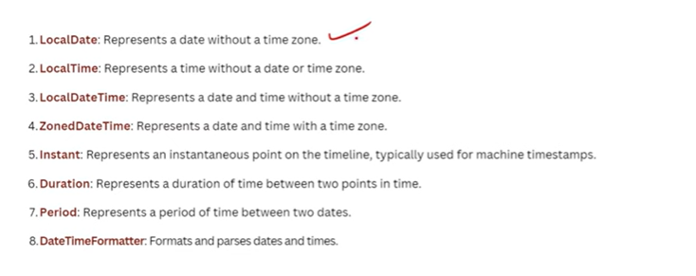
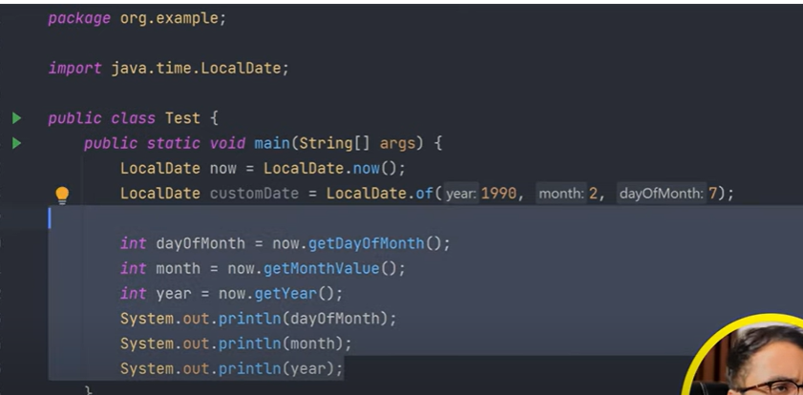

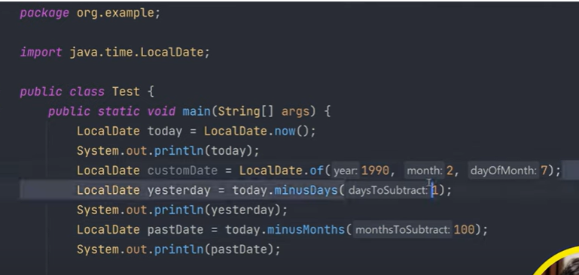

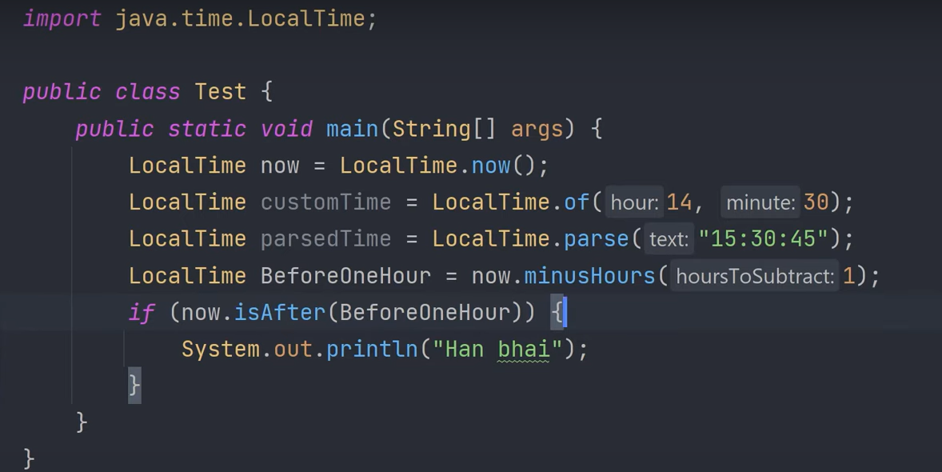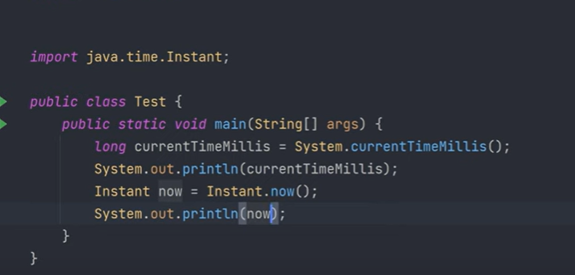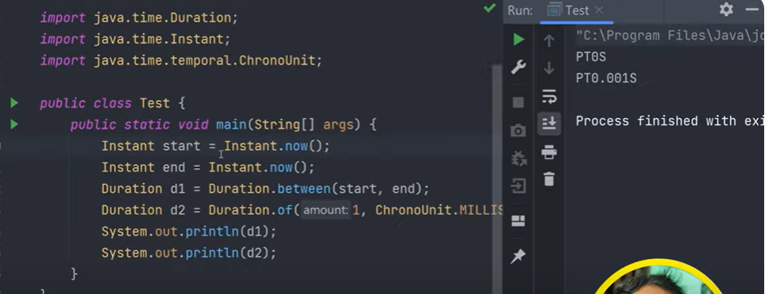

Optional class
The Optional class in Java 8 is a key feature introduced to address the issue of null references and to avoid NullPointerException. It provides a more elegant way to handle situations where a value might be present or absent, thereby making your code more readable and less error-prone.
1 . Creating an Optional
- Empty Optional: Represents the absence of a value
Optional<String> emptyOpt = Optional.empty();
Optional with a Value: Wraps a non-null value
Optional<String> opt = Optional.of("Hello");
Optional that May be Null: Allows for a null value, in which case it creates an empty Optional.
Optional<String> optNullable = Optional.ofNullable(null);

2 .Checking for a Value
- isPresent(): Returns true if there’s a value, otherwise false
if (opt.isPresent()) {
System.out.println(opt.get());

}
ifPresent(): Executes a block of code if a value is present
opt.ifPresent(value -> System.out.println(value));
3 . Retrieving the Value
- get(): Returns the value if present; throws NoSuchElementException if no value is present.
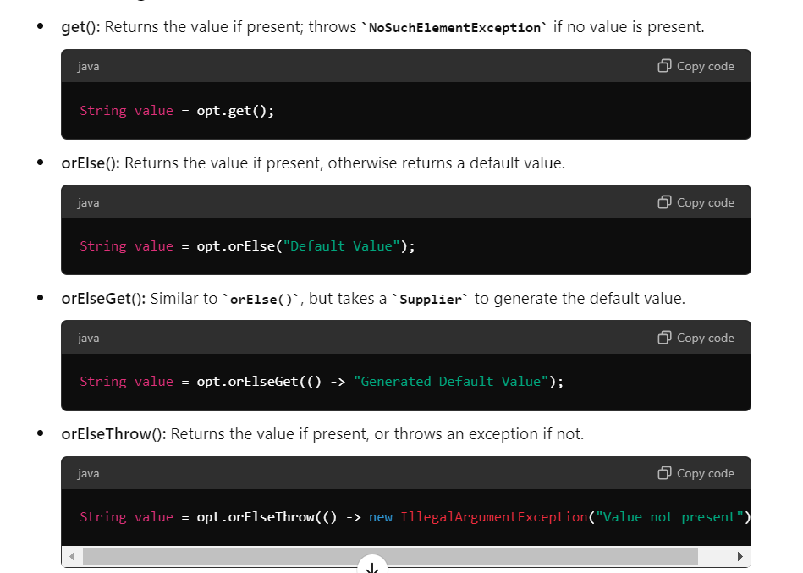
- Transforming the Value
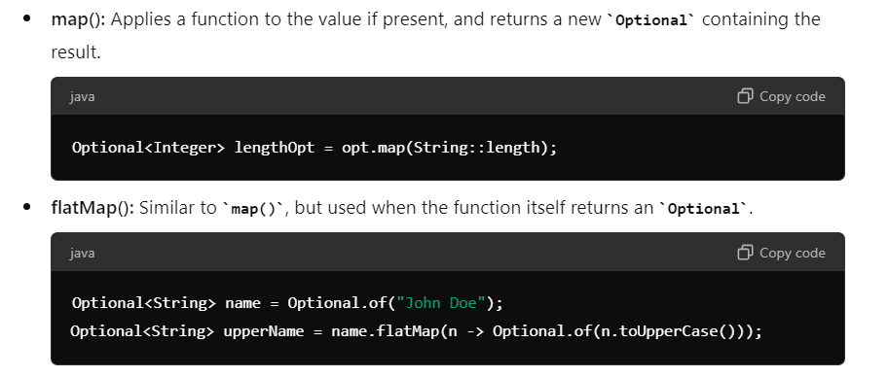
- Filtering the value
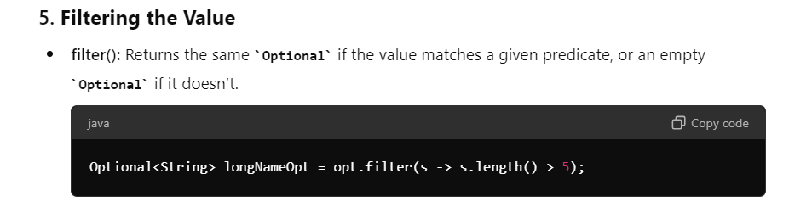

6. Common Use Cases
- Avoiding Null Checks: Instead of checking if an object is null before using it, you can use Optional to encapsulate the null check.
- Returning Values from Methods: Use Optional as a return type for methods where the result might be missing, avoiding returning null.
- Chaining Operations: Optional allows chaining of methods, making the code more concise and readable.

Example:
Here's a simple example demonstrating the use of Optional in a method:
public Optional<String> getUserEmail(String userId) {
User user = userRepository.findUserById(userId);
return Optional.ofNullable(user).map(User::getEmail);
}
// Usage
Optional<String> emailOpt = getUserEmail("123");
emailOpt.ifPresent(email -> System.out.println("Email: " + email));

Reduce () : terminal Operator
The reduce() method in Java 8 is a terminal operation used to reduce the elements of a stream into a single value. It takes a binary operator (a function that combines two elements into one) and applies it repeatedly to the elements of the stream to produce a final result.
The reduce() method is part of the Java Stream API and is commonly used to accumulate or combine elements, such as summing numbers, concatenating strings, or finding minimum/maximum values.

